

USER GUIDE

**LAB AUTOMATION**

**ACCP 2.0 (Batch: NK_2201G1)**

*Project Instructor*

**Sir Muhammad Muneeb Ullah Khan**

Submitted by:

**Abdullah Student1359157**

**Adeen Ahmed khan Student1355497**

**Muhammad Faiq Haider Student1357940**

**Snap Shots of website:**

**“Section 1: Log In page & Customer Register Page”**

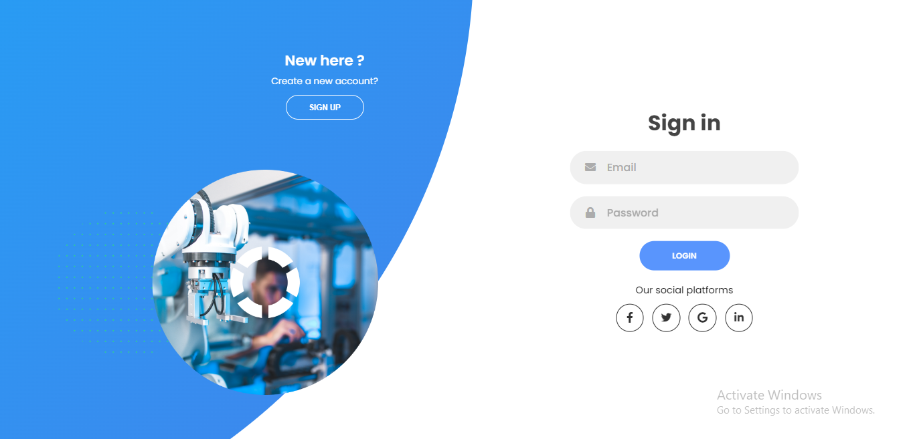



**“Section 2: Customer Home Page”**

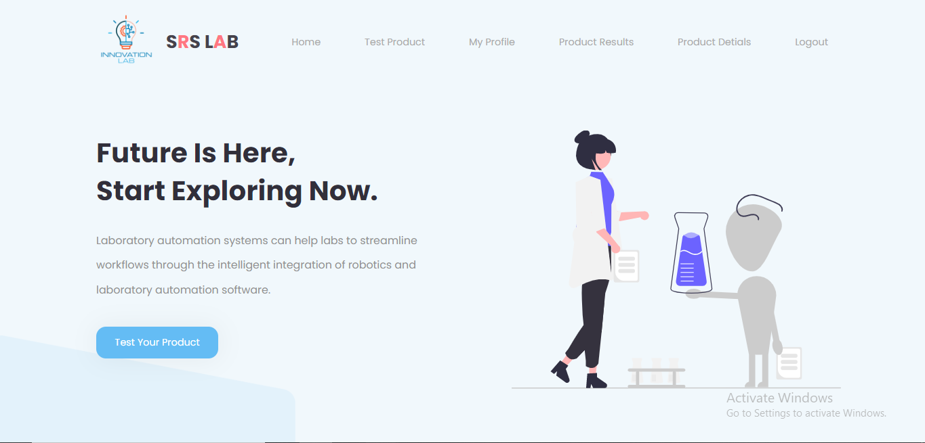

**“Section 3: Customer My Profile Page”**

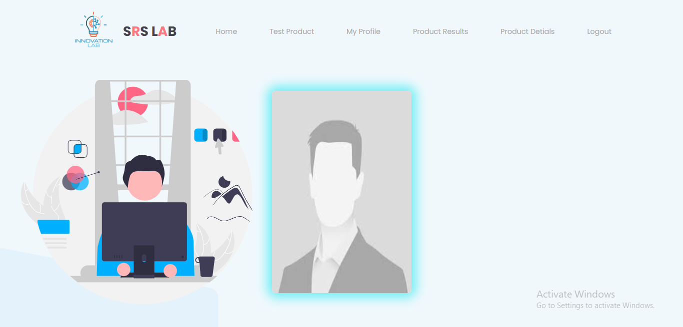

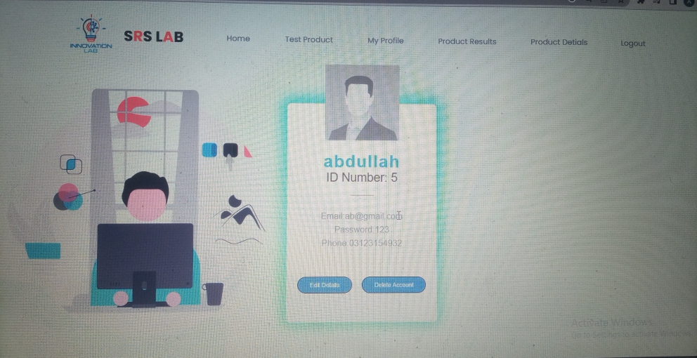

**Section 4: Edit Customer Profile Page”**

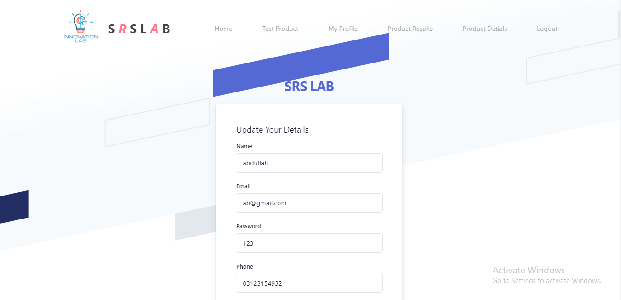

* In this page you update the details of customer

**“Section 5: “Send Product for Test”**

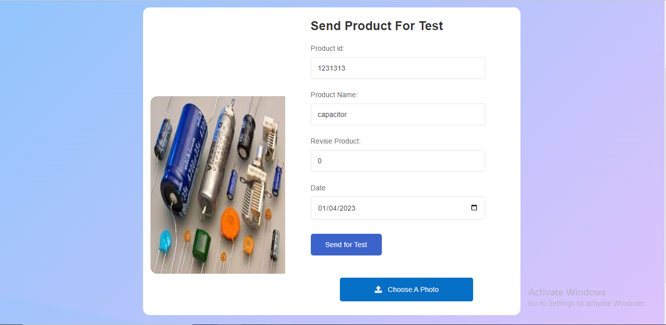

* In this page customer send his product details to lab worker for testing

**“Section 6: “Customer Product Details”**

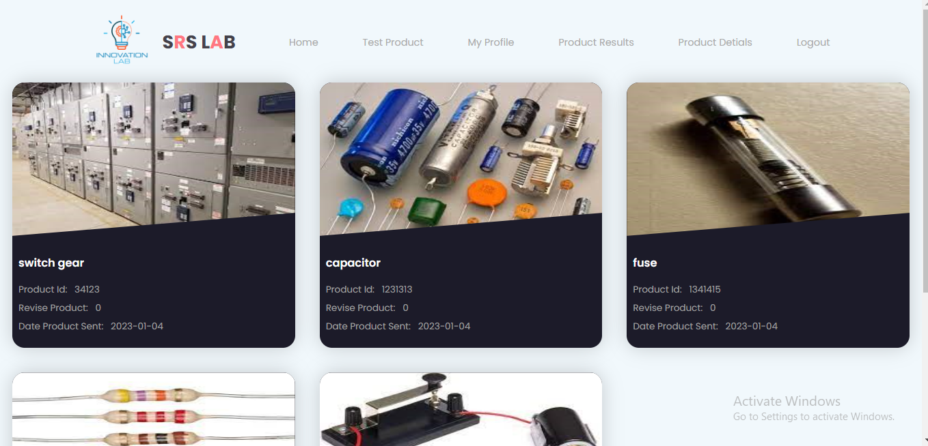

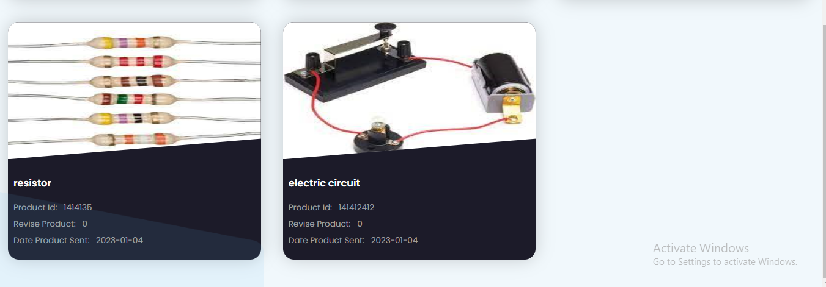

* In this page customer view his product detail he/her sent for testing until Lab worker start testing this product

**“Section 6: “Customer Product Results”**

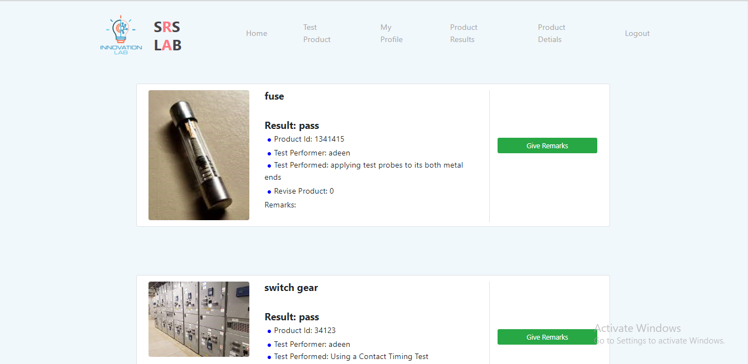

* **In this page customer view his product results**

**“Section 6: “Customer Product Results Review”**

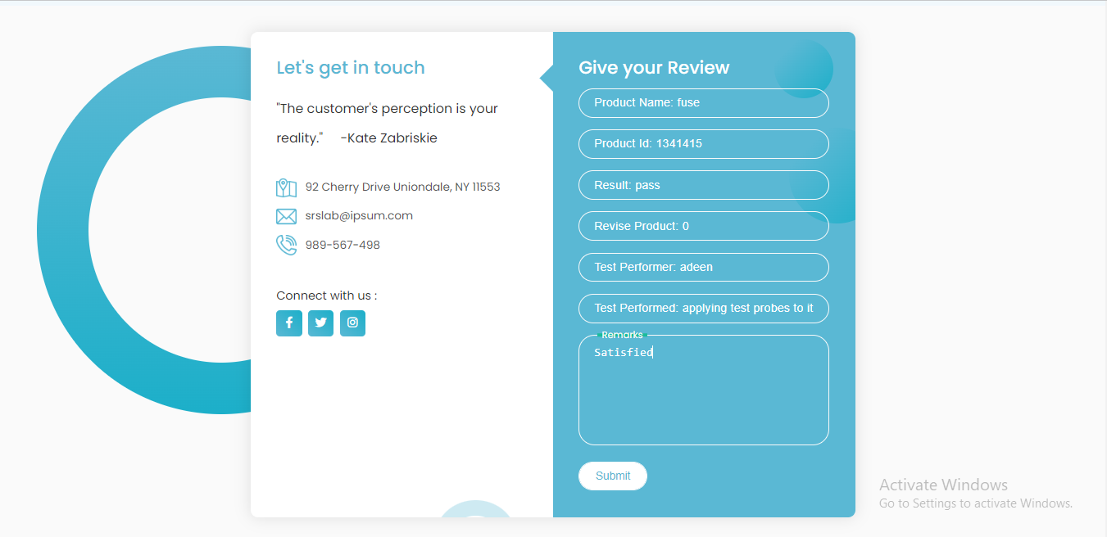

**In this page customer give review about testing**

**“Section 7: “Lab Worker Home Page”**

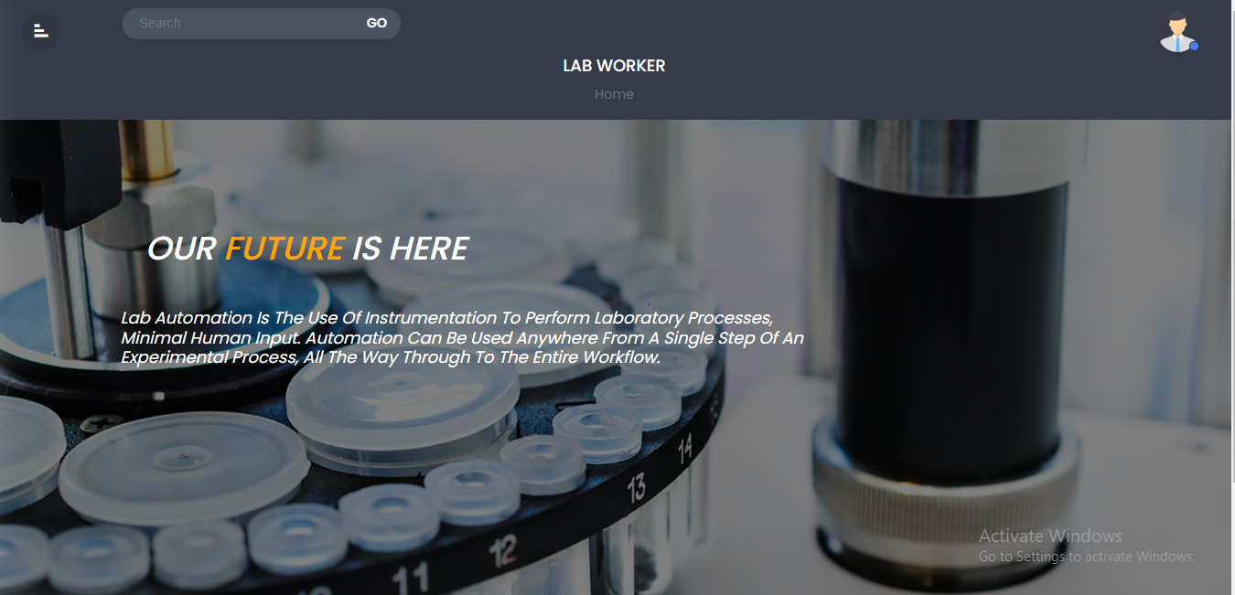

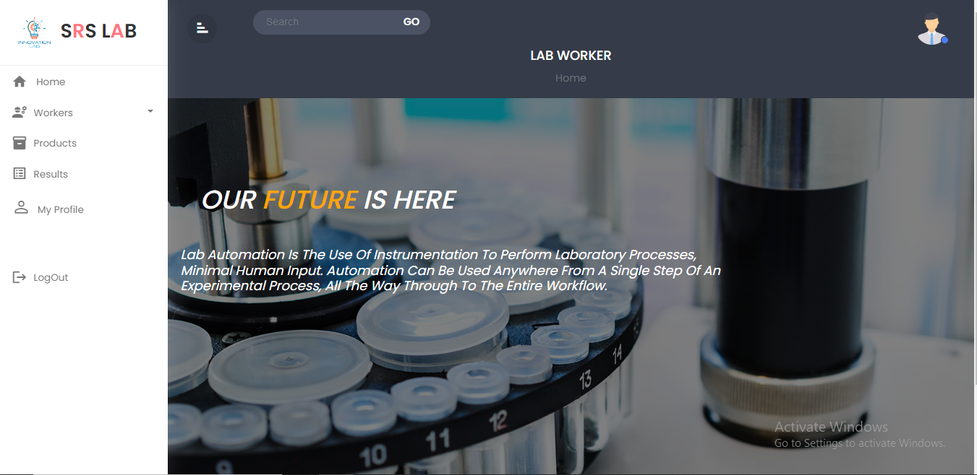

**“Section 8: “Lab Worker Details Page”**

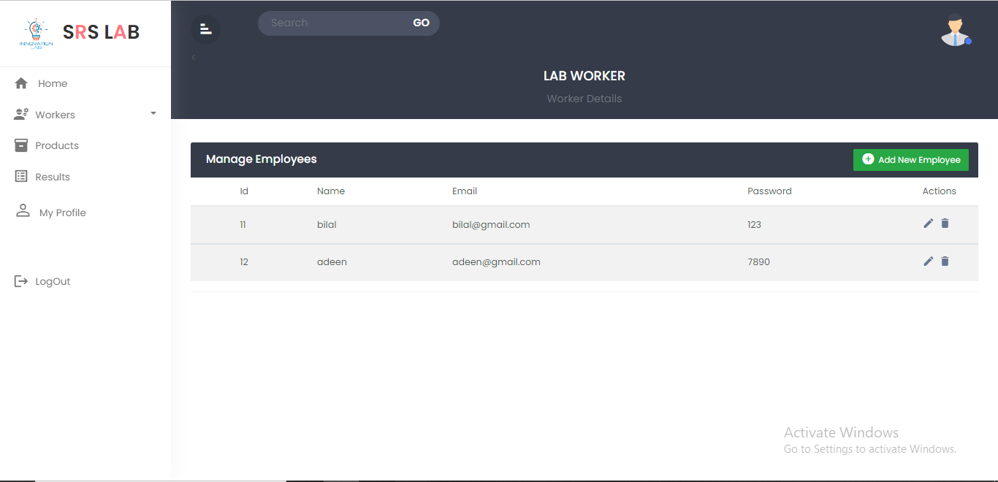

* **In this page worker view all worker details**

**“Section 9: “Create Lab Worker Page ”**

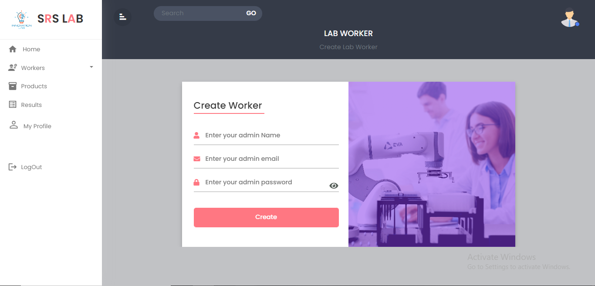

* In this page worker can create a worker account

**“Section 10: “Lab Worker Product Details Page”**

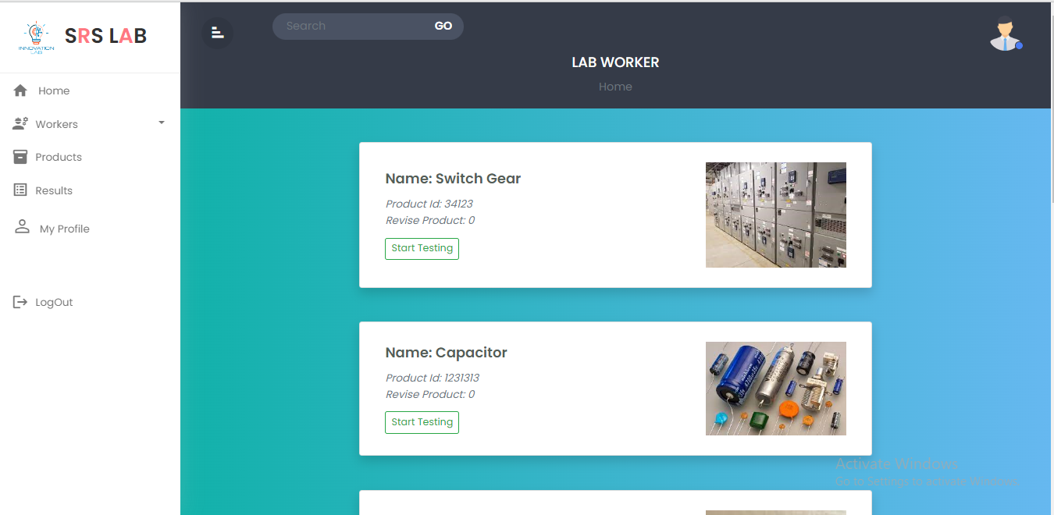

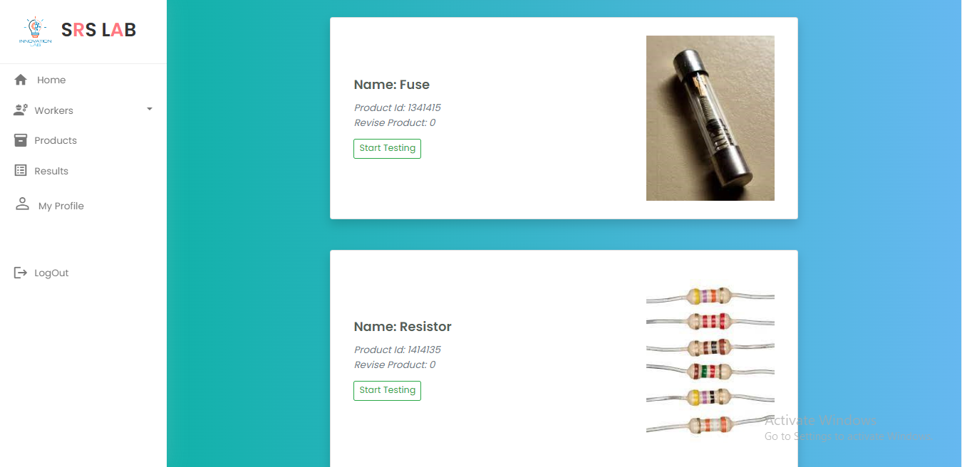

* In this page worker view the details of product customer sent for testing and by click on the start testing button it start testing

**“Section 11: “Lab Worker Details Page”**

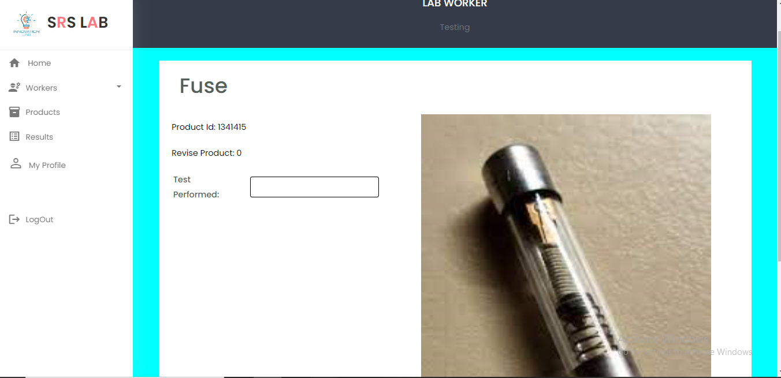

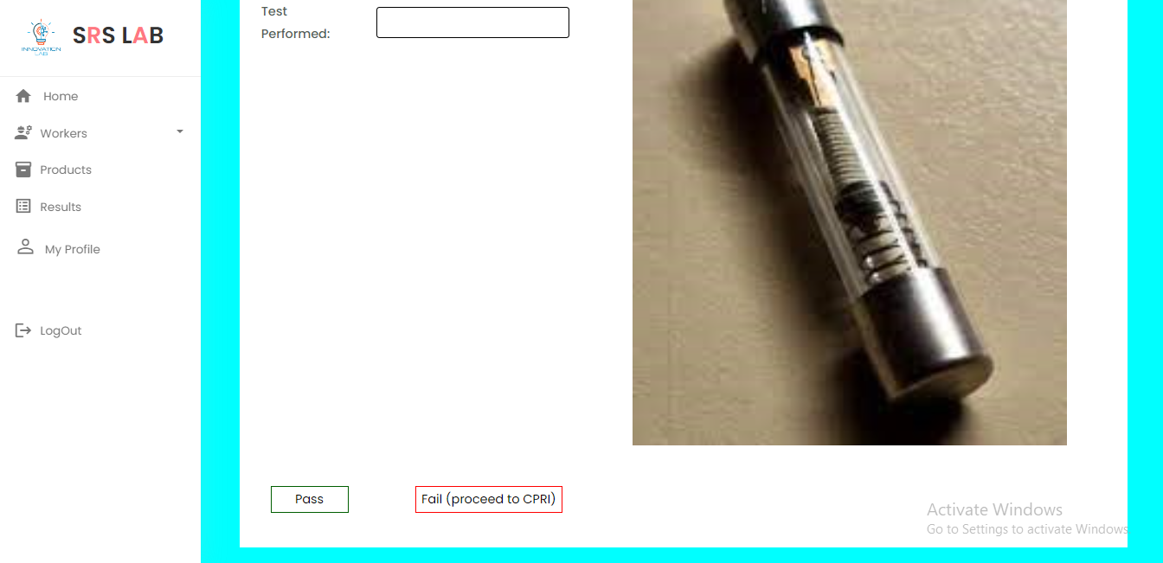

* In this page worker enter the test which has performed and by click on pass button the test was pass and product are eligible to release the in to the market.
* And by pressing fail button it will proceed to CPRI worker for further testing

**“Section 12: “Lab Worker Product Result Details Page”**

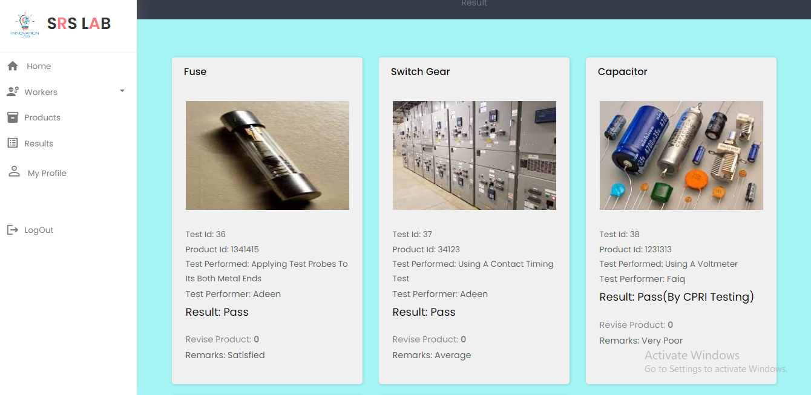

* **In this page Lab worker view the product results**

**“Section 13: “Lab Worker My Profile Page”**

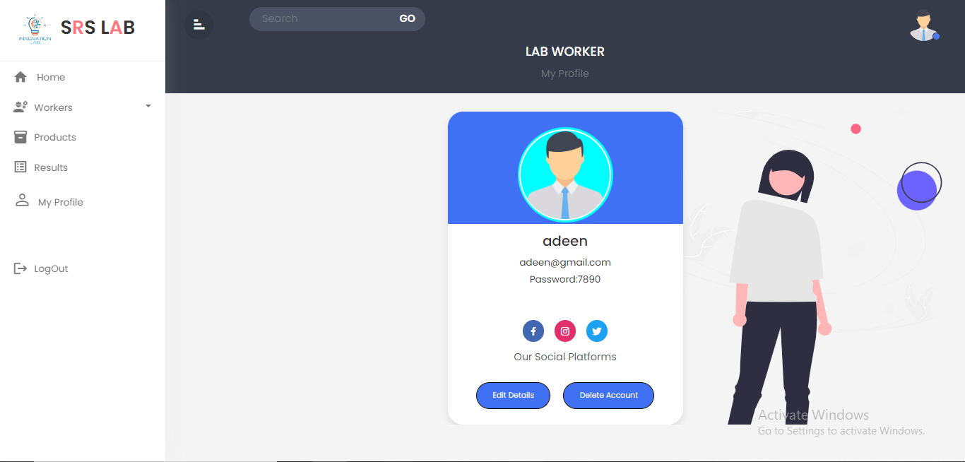

**“Section 14: “Lab Worker Edit My Profile Page”**

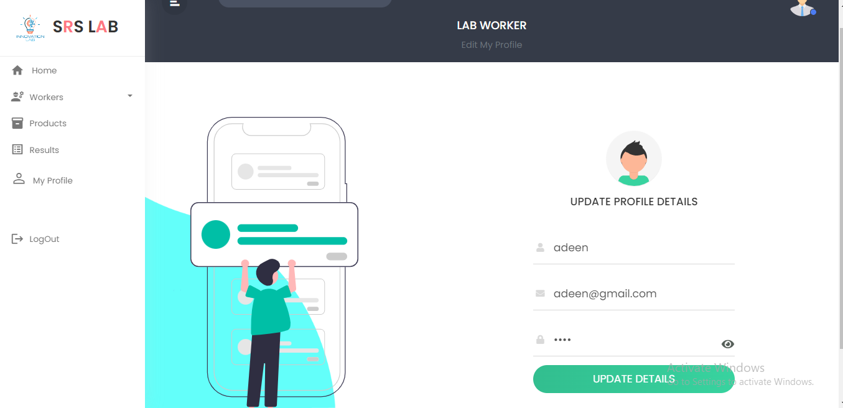

* **In this page Lab worker will update his profile details**

**“Section 15: “CPRI Worker Home Page”**





**“Section 16: “Create CPRI Worker Page”**



* In this page worker can create a worker account

**“Section 17: “CPRI Worker Details Page”**

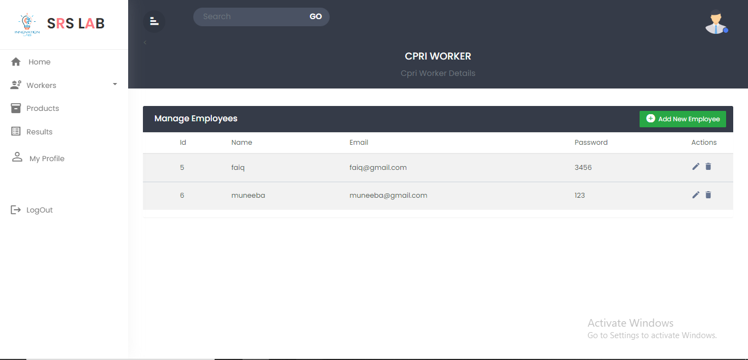

* **In this page worker view all worker details**
* **Section 18: “CPRI Product Details Page”**

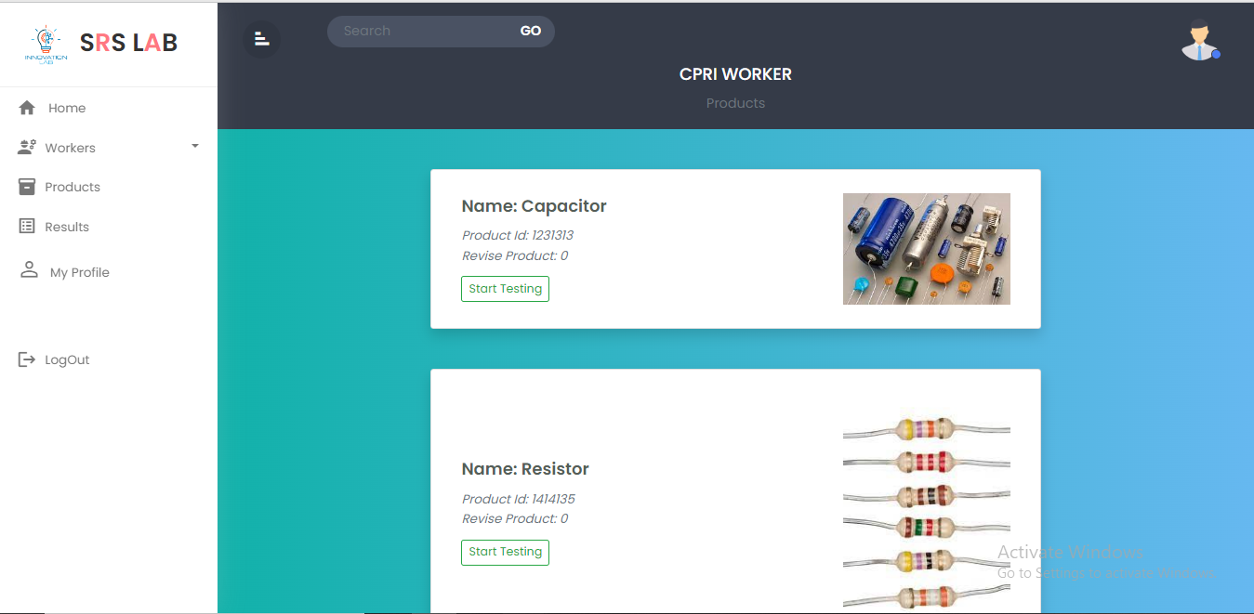

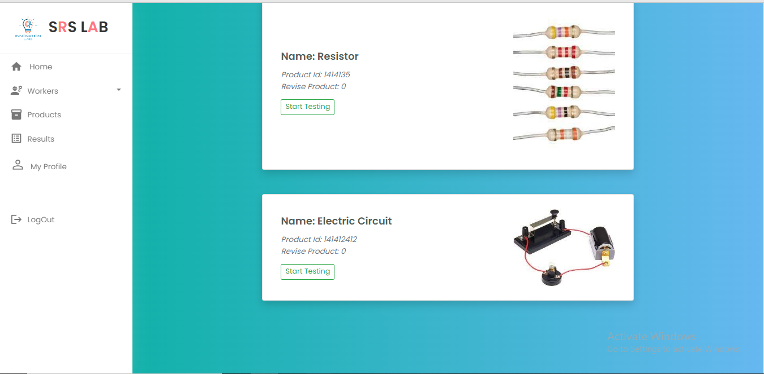

* In this CPRI worker view the product which are sent by Lab Worker

**Section 19: “CPRI Product Details Page”**

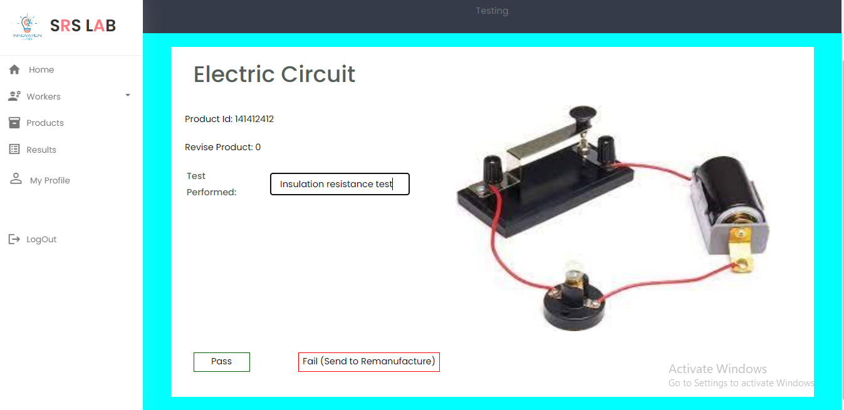

* **In this page CPRI worker fill the test details and by pressing pass button the product are free for released in market and by pressing fail it will return for remanufacture it**

**Section 20: “CPRI Product Result Page”**

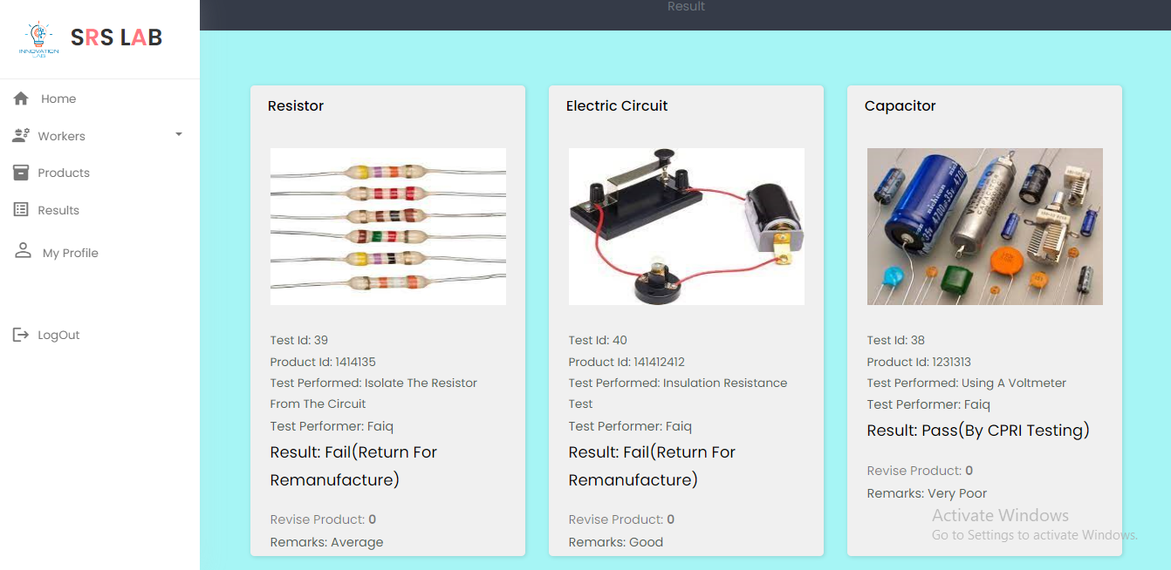

* **In this Page CPRI worker view the result of products**

**“*End*”**